#Playground Setup

If you are using Beeks Beacons you must first configure as the following:

-to configure beeks becons we use BEEKS Beacon Marker : <https://drive.google.com/open?id=0B_SXGEKN91UQUVlyWTFROGJ4S28>

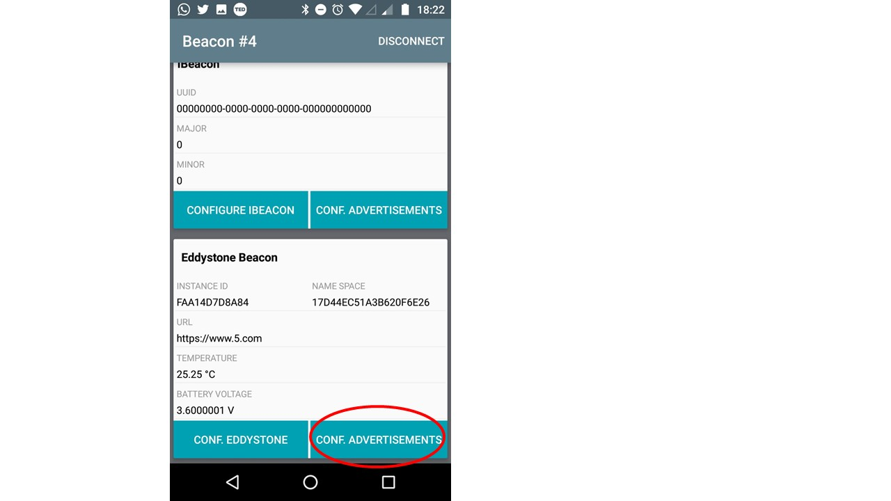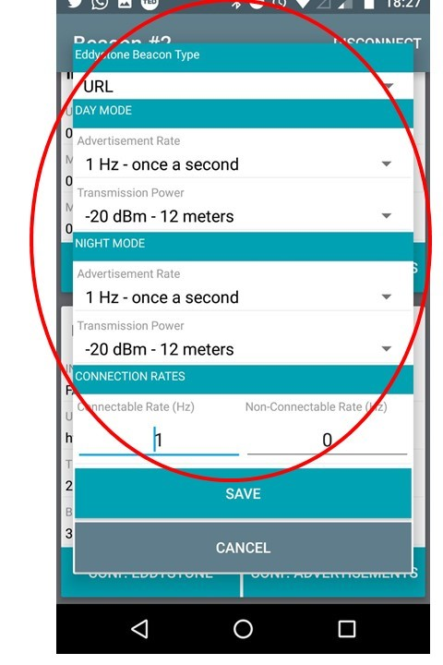

*Note :If you are using a different type of beacons you just must configure beacons the same as the screenshots using the app of the brand who corresponds to your beacon*

After setting the beacons the same as the screenshots you must draw coordinates with RSSI (Received Signal Strength Indicator) fingerprinting techniques, We use fingerprinting techniques like the [paper published by California Polytechnic State University](https://gitlab.com/EiderDiaz/Environmental-intelligence/blob/master/Fingerprinting.pdf) , In the same way, the beacons must be at strategically placed points through the building or room. These beacons will emit their signal, these signals will be catch by a device with Android 4.3+ and a Bluetooth Low Energy chipset (we use Motorola G4 with Android 7.0) with our mobile app which will measure the strength of the signals received, compare the signals and finally calculate the location.

In our experiment the coordinates and placement of the beacons is as follows:

